Card Payment Authorization Form
Complete with block letters and return to: ASSZISZTENCIA Kft. – Fax: (+36 1) 350 0929 - Email: info@asszisztencia.hu

Order Information

Conference name

Participant

Registration fee EUR

Other optional orders EUR

Total order EUR

Card information

Card type  MasterCard  VISA  American Express

Cardholder’s name
(as on card)

Cardholder’s address
(as it is registered at the bank)

Card number |_|_|_|_| - |_|_|_|_| - |_|_|_|_| -|_|_|_|_|
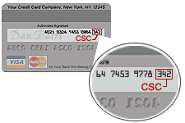

Expiry (month/year) |_|_| / |_|_|

Card Security Code* |_|_|_|

The Card Security Code (CSC) is a 3-digit security code that is printed on the back of your Visa or MasterCard.
The number appears on the signature strip after the last four digits of your account number.
The signature strip may contain your entire account number or just the last four digits of your account number.
Either way, the CSC will appear after the last four digits of your account number.
The CSC is used to verify that you have possession of the credit card you are attempting to use.

I, undersigned authorize ASSZISZTENCIA Kft. to debit the above total order sum to my card as a payment of my conference costs

Place, date:

Cardholder’s Signature

